Changes at a glance
These will be the same devices that you’ve used in the past. The differences are mostly visual, with some slight variation in the information that you can see.
Landing page comparison:
The applications will be very similar. You’ll notice there is no “Prep Mobile” on the new configuration, and the background is different. The new configuration also has an “AAG Shortcuts” icon. This takes you to a webpage with numerous Apple American Group links.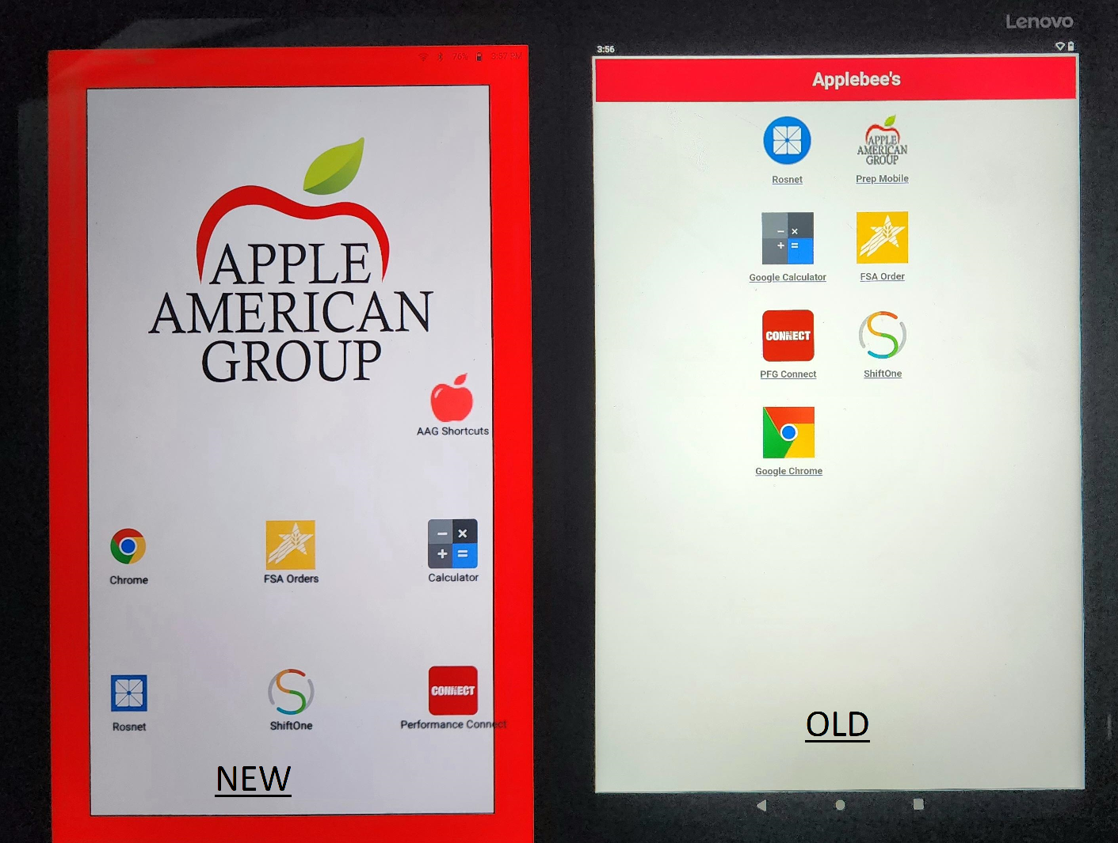

The included applications will work the same way as before, and associated work accounts should log in as normal.

The applications themselves will function in the same manner, and may only have slight visual differences based on the version of the tablet’s OS, or updated version of the applications.

Drop Down Menu:
The drop down menu will interact slightly different. When dragging down, the first options that should show up are “Wifi” and “Device Info”. Selecting Device Info, Open Android Device Policy, and then selecting “Device Info your IT Admin can see” will show device information that can be used to identify the device. Those steps are below:
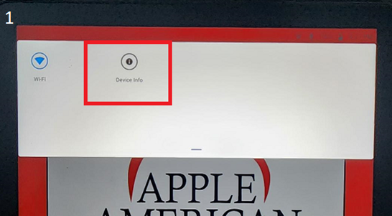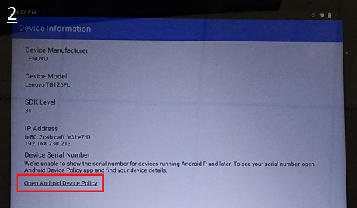
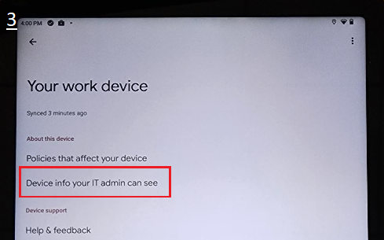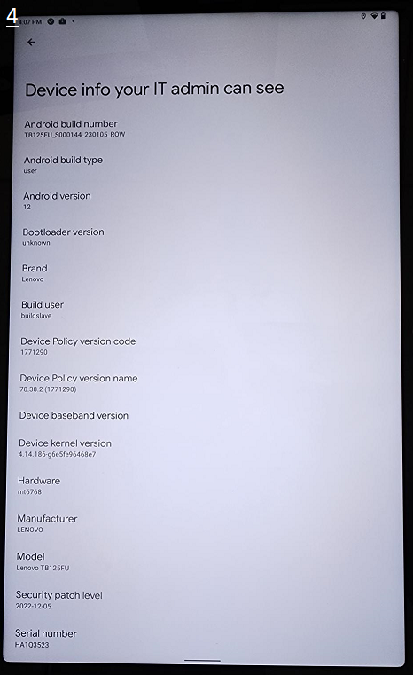

Drop Down Cont’d:
To drag down the system bar to view notifications or other miscellaneous items that would appear in the system bar, drag down from the top and you will see the Wifi and Device Info icons. Swipe down once again and the system bar will open. You can view notifications, system messages, etc. 